**SMART CAR PARKING SYSTEM**

* NAME : M.ANANTH
* REG NO. :953021106004
* COLLEGE CODE :9530
* COLLEGE NAME :ST. MOTHER THERESA ENGINEERING COLLEGE
* NAAN MUDHALVAN:au953021106004
* TEAM NAME :

**Smart Parking System Project Concept**:

This smart parking system project consists of Arduino, six IR sensors, one servo motor, and one LCD display. Where the Arduino is the main microcontroller that controls the whole system. Two IR sensors are used at the entry and exit gates to detect vehicle entry and exit in the parking area. And other four IR sensors are used to detect the parking slot availability. The servo motor is placed at the entry and exit gate that is used to open and close the gates. Also, an LCD display is placed at the entrance, which is used to show the availability of parking slots in the parking area.

**CIRCUIT DIAGRAM:**

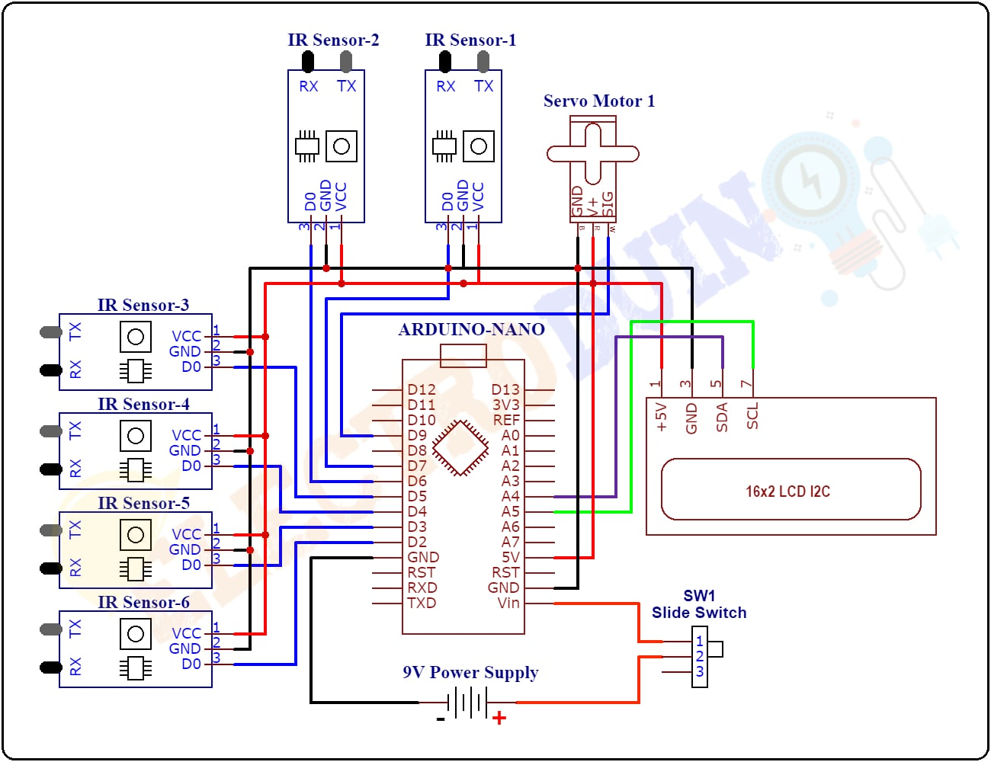

**BLOCK DIAGRAM**:

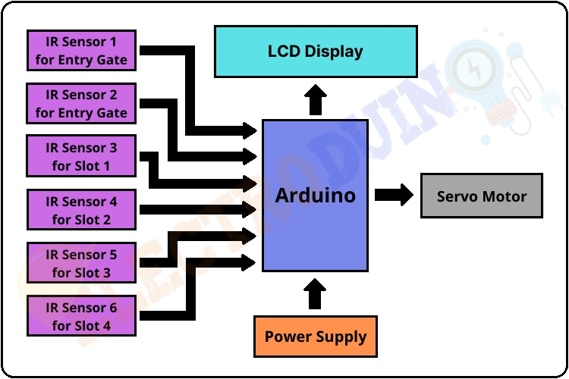

**COMPONENTS REQUIRED:**

|  |  |
| --- | --- |
| **Components Name** | **Quantity** |
| Arduino Nano or Arduino Uno | 1 |
| USB Cable for Arduino | 1 |
| IR Sensor | 6 |
| Sg90 Servo Motor | 1 |
| 9V power supply | 1 |
| PCB board or Breadboard | 1 |
| Connecting wires | As required in the circuit diagram |

**WORKING PRINCIPLE:**

After assembling all components according to the circuit diagram and uploading the code to the Arduino board. Now place the sensors and servo motor at accurate positions.

There are four parking slots in this project, IR sensor-3, 4, 5, and 6 are placed at slot-1, 2, 3, and 4 respectively. IR sensor-1 and 2 are placed at the entry and exit gate respectively and a servo motor is used to operate the common single entry and exit gate. The LCD display is placed near the entry gate.

The system used IR sensor-3, 4, 5, and 6 to detect whether the parking slot is empty or not and IR sensor-1, and 2 for detecting vehicles arriving or not at the gate.

In the beginning, when all parking slots are empty, then the LCD display shows all slots are empty.

When a vehicle arrives at the gate of the parking area then the IR sensor-1 detects the vehicle and the system allowed to enter that vehicle by opening the servo barrier. After entering into the parking area when that vehicle occupies a slot then the LED display shows that the slot is full. In this way, this system automatically allows 4 vehicles.

In case the parking is full, the system blocked the entrance gate by closing the servo barrier. And the LED display shows that slot-1, 2, 3, and 4 all are full.

When a vehicle leaves a slot and arrives at the gate of the parking area then the IR sensor-2 detects that vehicle and the system open the servo barrier. Then the LED display shows that the slot is empty. Again the system will allow entering a new vehicle.